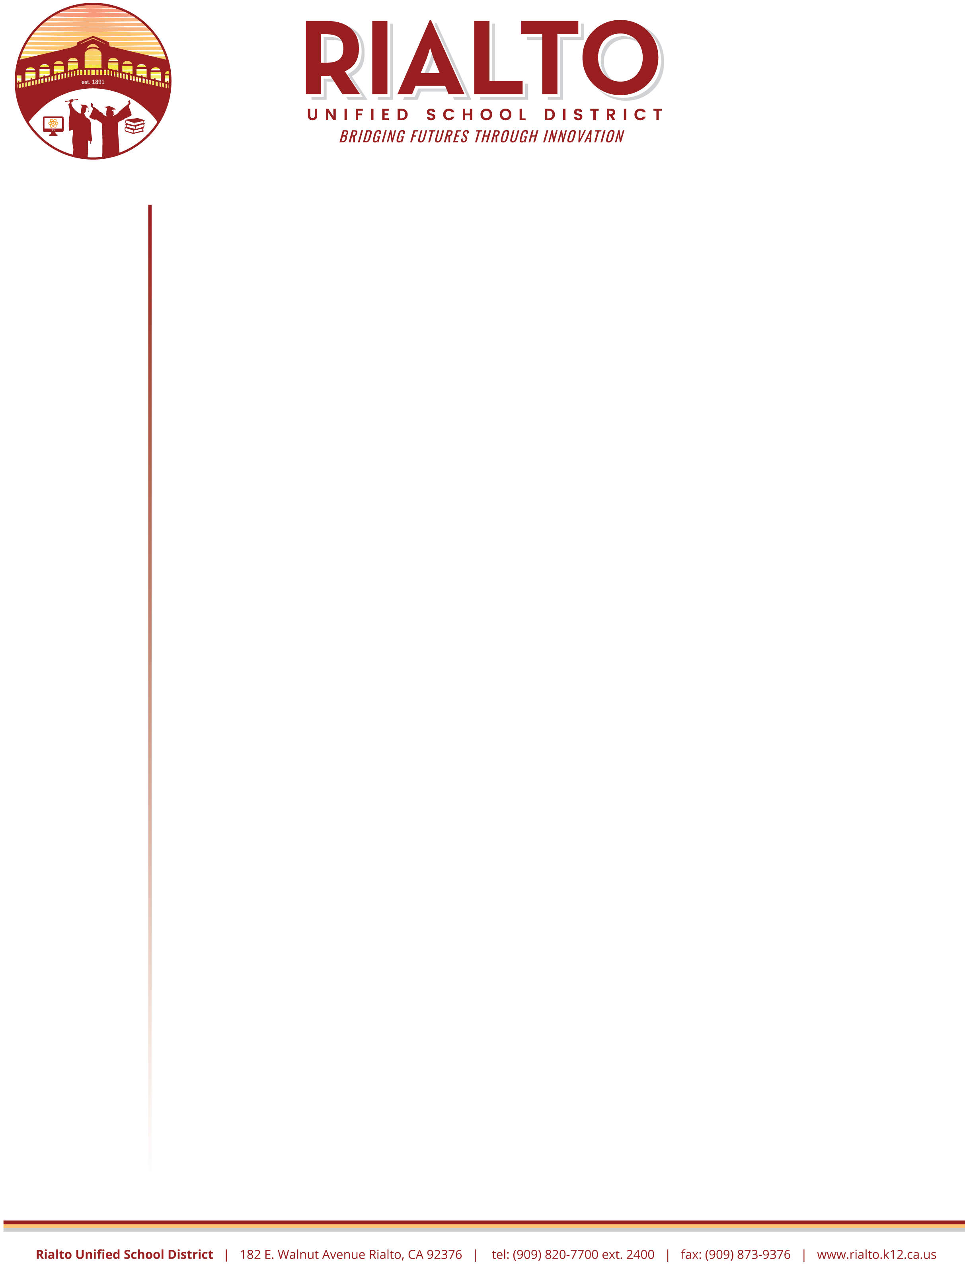

September 1, 2020

Dear Parents/Guardians,

Thank you for your support, as we work together to meet the challenges of our current situation.

We ask that you sign the *Technology-based Instructional Materials Waiver* that is posted here. It is possible that you previously signed this waiver through Parent Vue, but because of the malware attack we are asking that you sign the waiver again, and submit it to your child’s science teacher.

This waiver acknowledges that your child has access to an internet access device (like a: computer, Chromebook, cell phone, kindle, etc.) and is able to access the digital flexbook for science.  To return the form, there are 4 options for your convenience:

1. Your child’s teacher has assigned this as a class assignment in Google Classroom.  To access the Google Doc version of this waiver, ask your child to log in to their science Google Classroom.  Use the insert tab to digitally sign the document.  “Turn in” the waiver to your child’s science teacher through Google Classroom.
2. Access the Google Doc version of this waiver from the school website.  Use the insert tab to digitally sign the document. E-mail the waiver to your child’s science teacher.

**An instructional video about how to digitally sign the waiver can be found here:**

**English**



1. Print the waiver.  Sign the waiver and take a clear digital photo of the document, including the signature.  Then e-mail the picture to your child’s science teacher.
2. Print the waiver. Sign the waiver and drop the form off at the school site.

If you have additional questions about the *Technology-based Instructional Materials Waiver*. please feel free to contact your child’s science teacher, the school office, or the Rialto USD STEM Department at (909) 879-6002 ext. 2977 at your earliest convenience.

Respectfully,

Eva Serrato

**Rialto Unified School District |** 324 N. Palm Avenue Rialto, CA 92376 | (909) 879-6002 x 2980

**Board of Education**

**Nancy G. O’Kelley**

President

**Dina Walker**

Vice President

**Joseph Martinez**

Clerk

**Joseph Ayala**

Member

**Edgar Montes**

Member

**Superintendent**

**Dr. Cuauhtémoc Avila**

Superintendent

**Academic Agent**

**Eva Serrato**

Academic Agent